Project design

Team id | LTVIP2026TMIDS69886
Project name | Automated car catalog showroom management | system | for | enhanced
Proposed solution templet

Project team shall fill the following in formation in the solution template

S. No | Parameter | Description
1 | Problem statement (problem to be solved) | An automated car catalog system in ServiceNow to streamline showroom management through real-time inventory updates and enhanced operational efficiency
2 | Idea/description | An automated car catalog system in ServiceNow to streamline showroom management through real-time inventory updates and efficient data handling.
3 | Novelty/uniqueness | A unique integration of automated car cataloging with ServiceNow to enable real-time, intelligent showroom management and seamless service operations.
4 | Social impact/customer satisfaction | Enhancing showroom management with an automated car catalog system in ServiceNow improves customer satisfaction through faster service and accurate information, while promoting sustainable, tech-driven operations
5 | Business model(revenue model) | A subscription-based SaaS model offering automated car catalog and inventory management through ServiceNow to optimize showroom operations and customer experience.
6 | Scalability of the solution | The solution is highly scalable, allowing seamless integration of multiple showrooms and car models across regions within the ServiceNow platform.

Automated car catalog system for enhanced showroom management
What is catalog system
A catalog system in ServiceNow is a feature that allows users to request IT or business services through a structured and user-friendly interface. It organizes services into categories, making it easy for users to find and request items like software access, hardware, or support. Each request triggers workflows for approval and fulfillment, streamlining service delivery.

Types:

- IT Service Catalog – Offers IT services like password reset, software install.
- Business Service Catalog – Provides HR, finance, and other non-IT services.
- Technical Service Catalog – Contains backend services used by IT staff.
- Hardware Catalog – Lists physical assets like laptops, monitors, phones.
- Software Catalog – Offers software products and licenses for request.
- Facility Catalog – Requests related to office space, maintenance, or equipment.

Milestone 1:Service catalog Purpose:
- Streamlines vehicle listing and updates in real-time. o Simplifies car request and reservation workflows. o Enables role-based access for showroom staff.
- Improves tracking of vehicle availability and status. o Automates approvals and inventory management.
Uses:

- Streamlined Car Inventory Requests – Allows staff to request vehicle listings or updates with predefined forms.
- Automated Vehicle Onboarding – Simplifies adding new car models to the digital catalog through workflow automation.
- Real-Time Status Updates – Enables tracking of vehicle availability, maintenance, and delivery schedules.
- Role-Based Access – Controls who can view or modify catalog details, ensuring data integrity.
- Service Request Analytics – Provides insights into car-related service trends and showroom demands.

Activity 1:Create catalog

- Open service now.

- Click on All >> search for Maintain Catalog.

- Click on Maintain Catalog under Catalog Definition.

- After opening Maintain Catalog Click on new.

- Give Catalog Name as “Mahendra ”.

- Application should be Global.

- Give description as it is a car showroom.

- Click on Submit.
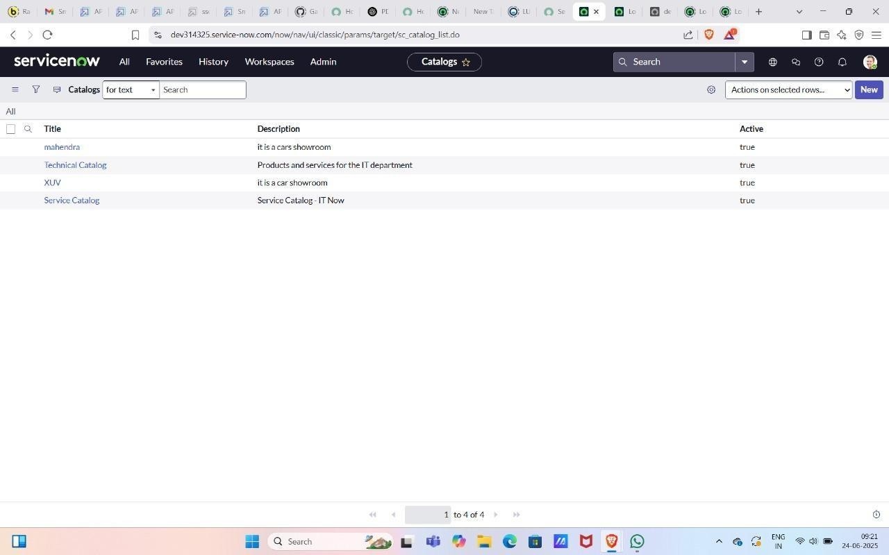

Activity 2:Create categories

  - After submitting you can see the catalog Mahindra in the list.
  - Open Mahendra Catalog Scroll down.
  - Click Categories And Click on New.
  - Give Title as Sudden.
  - Search and add catalog as Mahendra.
  - Click on submit

  - Create two more categories as XUV and Sports.
8.

- .
  - Click on Catalog Items and Click on new.
9Give it a name as polo.
10.Select catalog as Mahendra.
- Select category as Sudden.
- short description as Volkswagen Polo - Compact Hatchback with Superior Comfort and Efficiency.
- Give Description The Volkswagen Polo is a stylish and compact hatchback known for its agile performance, modern design, and premium features. Equipped with a 1.0-liter TSI engine, the Polo offers an impressive balance of power and fuel efficiency, making it an ideal choice for urban driving and longer journeys alike. This model includes advanced safety features, a touchscreen infotainment system, and spacious seating, ensuring comfort and convenience for all passengers. The Polo stands out with its sporty look, LED headlights, and alloy wheels, reflecting Volkswagen’s commitment to quality and design.

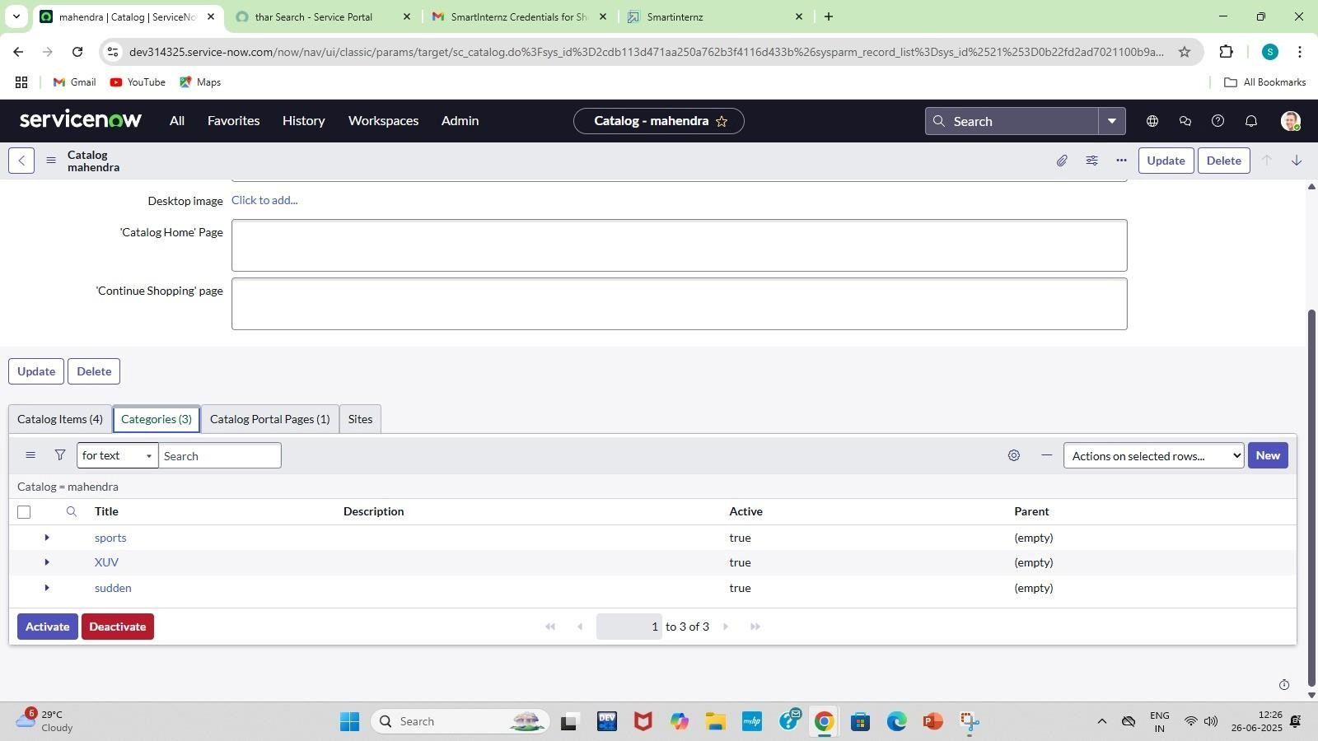
- Click on Picture and add image.

Milestone 2: User creation

Activity 1: User Creation

Purpose:

- Enable seamless addition and management of car inventory in the showroom. o Provide personalized access to car catalog data for sales and service staff. o Streamline user roles and permissions for catalog interaction and updates. o Facilitate efficient customer service through quick user-driven lookups.
- Support real-time updates and access to car features, pricing, and availability.

Uses:

- Assign showroom-specific permissions for accessing car catalog data. o Auto-link user profiles with relevant sales performance dashboards. o Enable personalized notifications for catalog updates or car arrivals. o Control user access to test drive scheduling and booking features.

- Open service now.
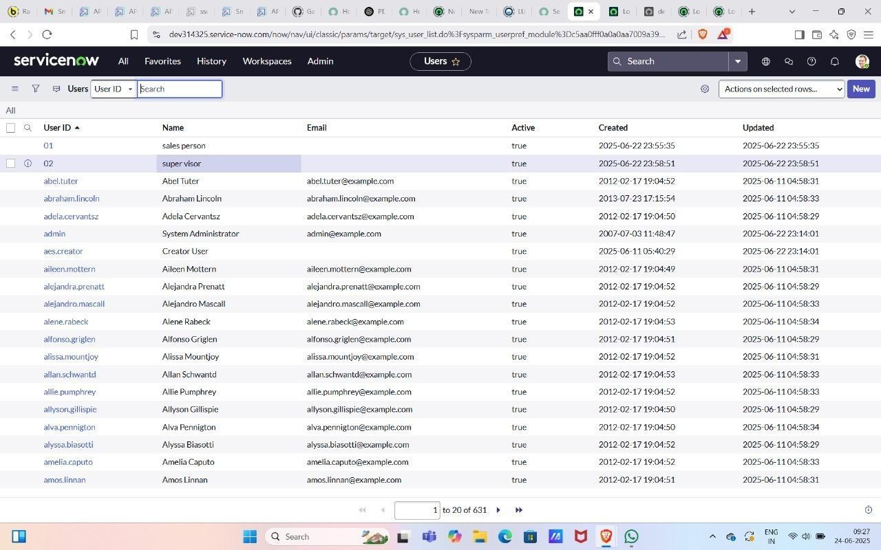
- Click on All >> search for Users.

- Click on Users>> under System Security.

- Click on new, give user ID as 01 and name as sales person and add the role emp1.

- Save and Submit. Milestone3: Role creation

Activity 1:Create roles
Purpose:

- Streamline inventory control by assigning catalog management roles. o Enhance customer service through dedicated sales and inquiry roles. o Ensure data accuracy with roles for catalog content validation. o Enable secure access via role-based permission settings.
- Facilitate workflow automation through role-specific task assignments.

Uses:

- Inventory Admin Role – Maintains car stock records and availability updates. o Service Technician Role – Logs maintenance schedules and service history. o Customer Service Role – Handles customer inquiries and booking processes.
- System Admin Role – Configures catalog workflows and manages user permissions.

- Click on the Service now logo and click on all and search for roles.

- Click on Roles >>Under system security.
- Click on new and give the name as emp1.

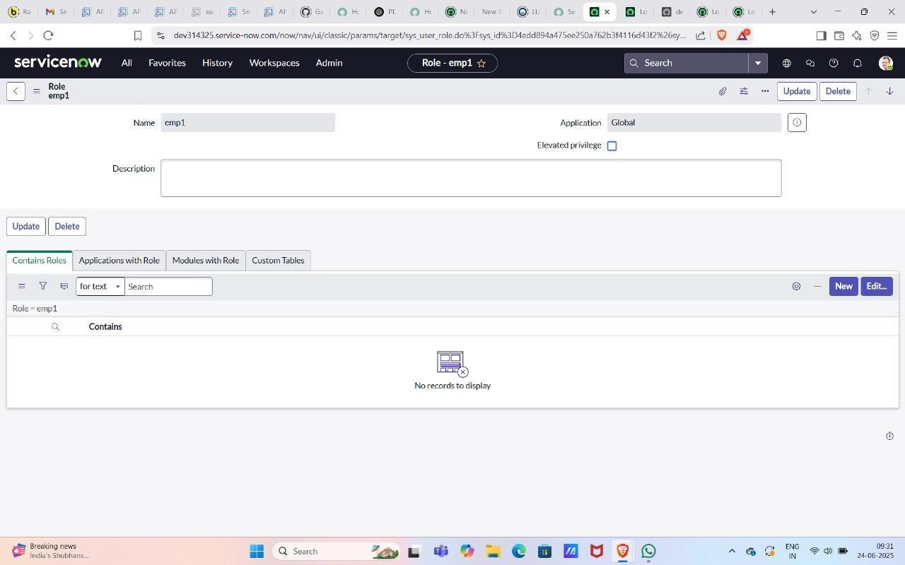
Milestone 4: Group creation

Activity 1: Create group

Purpose:

- Centralize vehicle data for easy access and updates. o Streamline car inventory tracking and availability. o Improve coordination across sales and service teams. o Automate workflows for faster car assignment and display.
- Enable real-time catalog updates and reporting in ServiceNow.

Uses:

- Streamlines vehicle inventory tracking with real-time updates.
- Automates new car entries and categorization in the catalog.
- Enables quick search and filtering of cars by features or availability. o Simplifies task assignment for vehicle preparation and servicing.
- Provides dashboards for showroom managers to monitor car status.

- Click on All>>Search for groups.

- Click on groups>>under Security System.

- Click on new and give the group's name as showroom.

- Give the group manager as Abraham Lincoln. And Submit.

- Add group members as Salesperson, Salesperson2 and 3.And update.



Milestone5: Table creation
Activity1:Create a table Purpose:

  - Centralize car inventory data for real-time access and updates.
  - Track vehicle specifications to assist in customer decision-making.
  - Manage showroom availability and vehicle status efficiently. o Enable automated workflows for test drives, bookings, and services.
  - Generate analytics and reports for sales and performance monitoring.

Uses:

  - Organizes vehicle data into structured tables for easy access and tracking.
  - Enables dynamic filtering of cars by model, price, and features for quick customer queries.
  - Supports real-time inventory updates to reflect showroom stock accurately.
  - Facilitates seamless integration with service and sales workflows. o Improves reporting and analytics by storing historical sales and service records.
In automated car catalog system, table creation in Service Now is used to structure and store
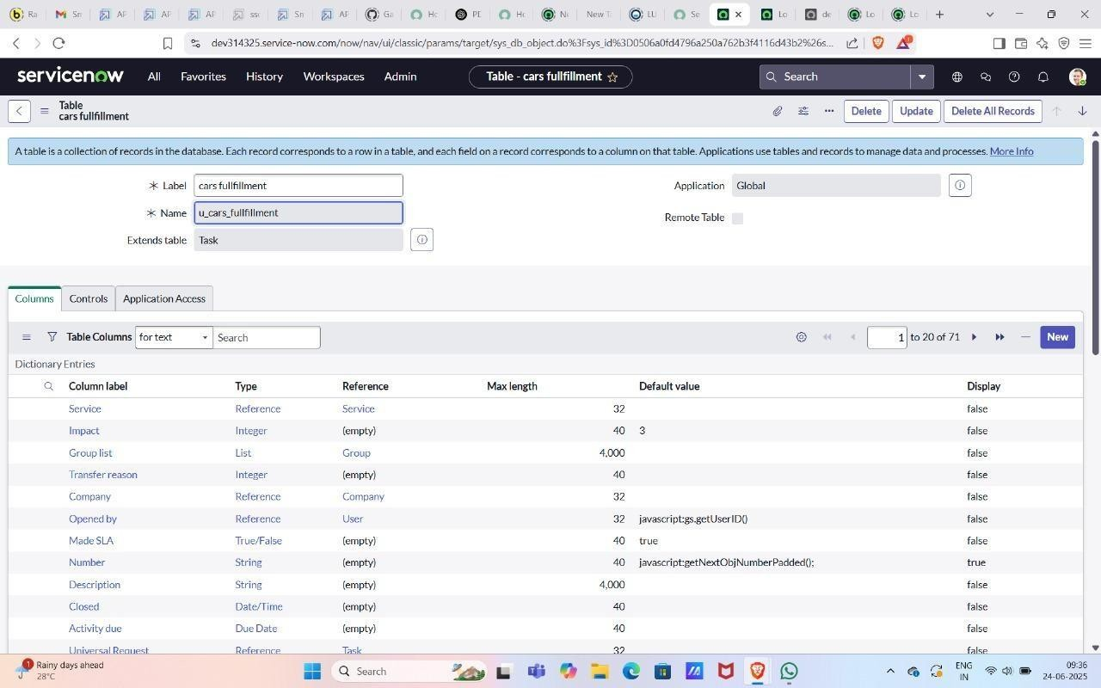
detailed data on cars, including specifications, availability, and pricing. These tables enable efficient data management, reporting, and integration with workflows for enhanced showroom operations.
- click on All>>Search for Tables.

- Click on Tables>>under System definition.

- Click on the new give name as cars fulfilment.

- Give extended table as Task table.

- Save and Submit.

Milestone 6: Workflow

Activity1: Workflow Assignment to Mahendra service Catalog.
Purpose:

  - Centralizes car inventory data for real-time visibility. o Automates vehicle listing and update processes. o Improves customer inquiry handling with quick access to specs.
  - Integrates service scheduling and vehicle availability.
  - Generates reports for sales and stock performance insights.

Uses:
o Auto-updates inventory – Syncs new car arrivals and availability in real-time. o Streamlines test drive scheduling – Automates customer booking and reminders.
  - Simplifies vehicle detail access – Centralizes specs, images, and pricing for sales teams.
  - Tracks customer interactions – Logs inquiries and preferences for follow-up.
  - Generates performance reports – Provides insights on popular models and sales trends.

  - Navigate to Homepage.
  - Click on all search Workflow Editor.
  - Click on New Workflow.
  - Under the name field search for Test Select that record.
  - After creating workflow you can see begin and end.
  - Drag the approval user from core and give name as sales.
  - Give the user as a sales person.
  - Drag the approval user from core and give name 2nd level.
  - .Add a user as supervisor.
  - Drag create task from core and give name as car company
- Give task type car fulfilment table and priority-1.
- Give task values from values
- Set values as car status Ready to Pickup.
- tate Closed Complete and submit.
- Drag the create task from core and give it name as car production.
16Give task type car fulfilment table and priority-1.
- Give task values from values
- Set values as car status deployment failed.
- State closed Incomplete.And Submit.
- Drag Notification from core and give name as Booking Notification.
- Add To user as Abraham Lincoln and group as Showroom.
- Give the subject as car showroom and message
<html>
<body style="font-family: Arial, sans-serif;">

<!-- Background Logo Wrapper --> <div style="background-image:
url('${C:\Users\saipr\OneDrive\Pictures\Screenshots\Screenshot 2024-10-28 125727.png}'); background-size: contain; background-repeat: no-repeat; background-position: center; padding:
20px; text-align: center;"> <!-- Background Logo Wrapper --> <div style="background-image:
url('${C:\Users\saipr\OneDrive\Pictures\Screenshots\Screenshot 2024-10-28 125727.png}'); background-size: contain; background-repeat: no-repeat; background-position: center; padding: 20px; text-align: center;">

<!-- Overlay Content -->
<div style="background: rgba(255, 255, 255, 0.8); padding: 20px; border-radius: 8px;">
<h2 style="color: #333;">Car Request Notification</h2>
<p style="color: #555;">
Hello, your request for a car model has been submitted and approved.
</p>

-- Dynamic Fields -->
<p><strong>Requested Car:</strong> ${requested_for}</p>
<p><strong>Status:</strong> ${approval}</p>

<p style="color: #333;">Thank you for choosing Mahendra!</p>
</div>

</div>

</body>

</html>
- Submit.
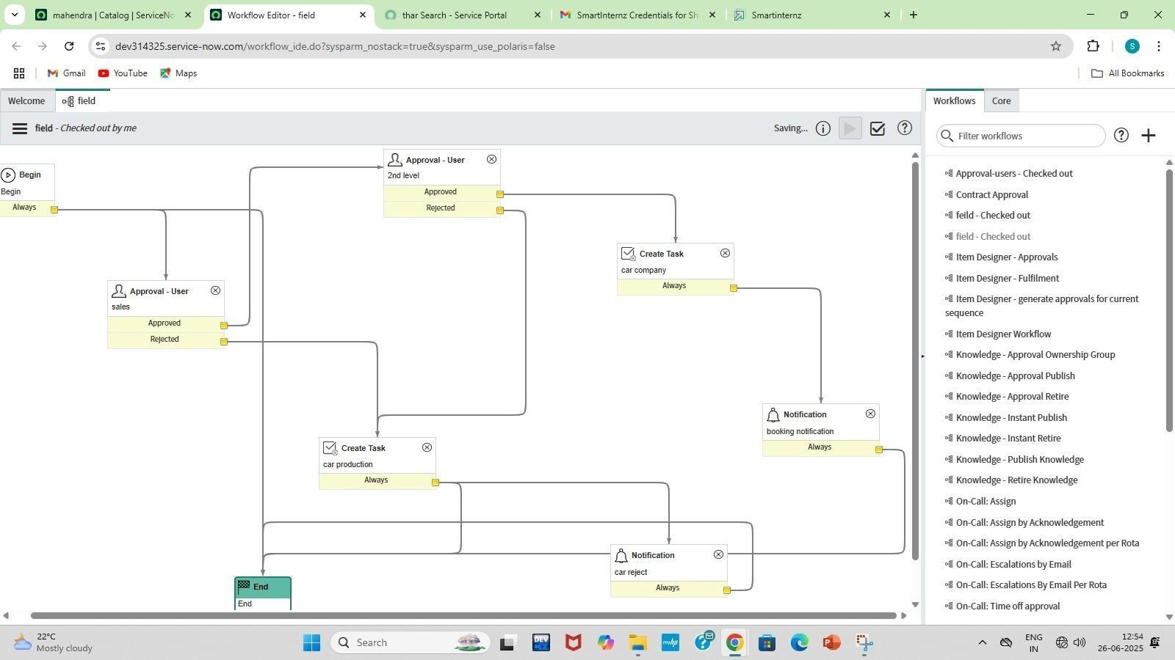
- Drag the Notification and give the name as car reject.

Milestone7: Service portal

Activity1: Searching created catalog are available in service portal

Purpose:

- Streamlines car inventory tracking and updates in real-time. o Enables quick access to detailed vehicle specifications for staff and customers. o Automates booking and test drive scheduling through the portal. o Improves customer experience with a self-service car catalog interface.
- Reduces manual errors and enhances operational efficiency in showroom workflows.
Uses:

- Real-time vehicle inventory updates for accurate showroom display. o Self-service car search and filter options for customers and staff. o Streamlined booking and test-drive scheduling directly via the portal. o Integrated maintenance history and service status for each vehicle.
- Automated notifications and alerts for stock changes or promotions.

- Check the cars are available in the service portal. And order it.

- To open a service portal copy the url of your instance up to com/ and give sp press enter for example(https://dev266346.service-now.com/sp).
- Search the catalog item which you are created.

.4.Search for thar. And order it.

- After ordering the car you get a request number and Delivery date.

- Search for thar. And order it.

- After ordering the car you get a request number and Delivery date.

Milestone8: Result Activity1:Check result
Purpose:
  - Streamlines car inventory tracking and updates in real-time.
  - Enhances customer experience with quick vehicle information access.
  - Automates car model categorization and availability status.
  - Reduces manual data entry errors and improves efficiency.
  - Integrates service requests and vehicle management seamlessly.

Uses:

  - Faster vehicle lookup and inventory updates.
  - Streamlined sales and service workflows.
  - Improved customer experience through real-time data.
  - Reduced manual errors and data redundancy.
  - Enhanced reporting and decision-making capabilities.

1.After ordering the car request is approved you get a mail the order will be delivered. And Based on your order being approved or rejected you will receive a rejected mail.
Conclusion

The Car Catalog System project for a car showroom in ServiceNow successfully addresses the need for a streamlined, automated approach to managing car catalog items, customer requests, and approval workflows. By organizing car models into easily navigable categories and leveraging ServiceNow's powerful automation features, the system enhances operational efficiency, reduces manual intervention, and improves customer satisfaction.

